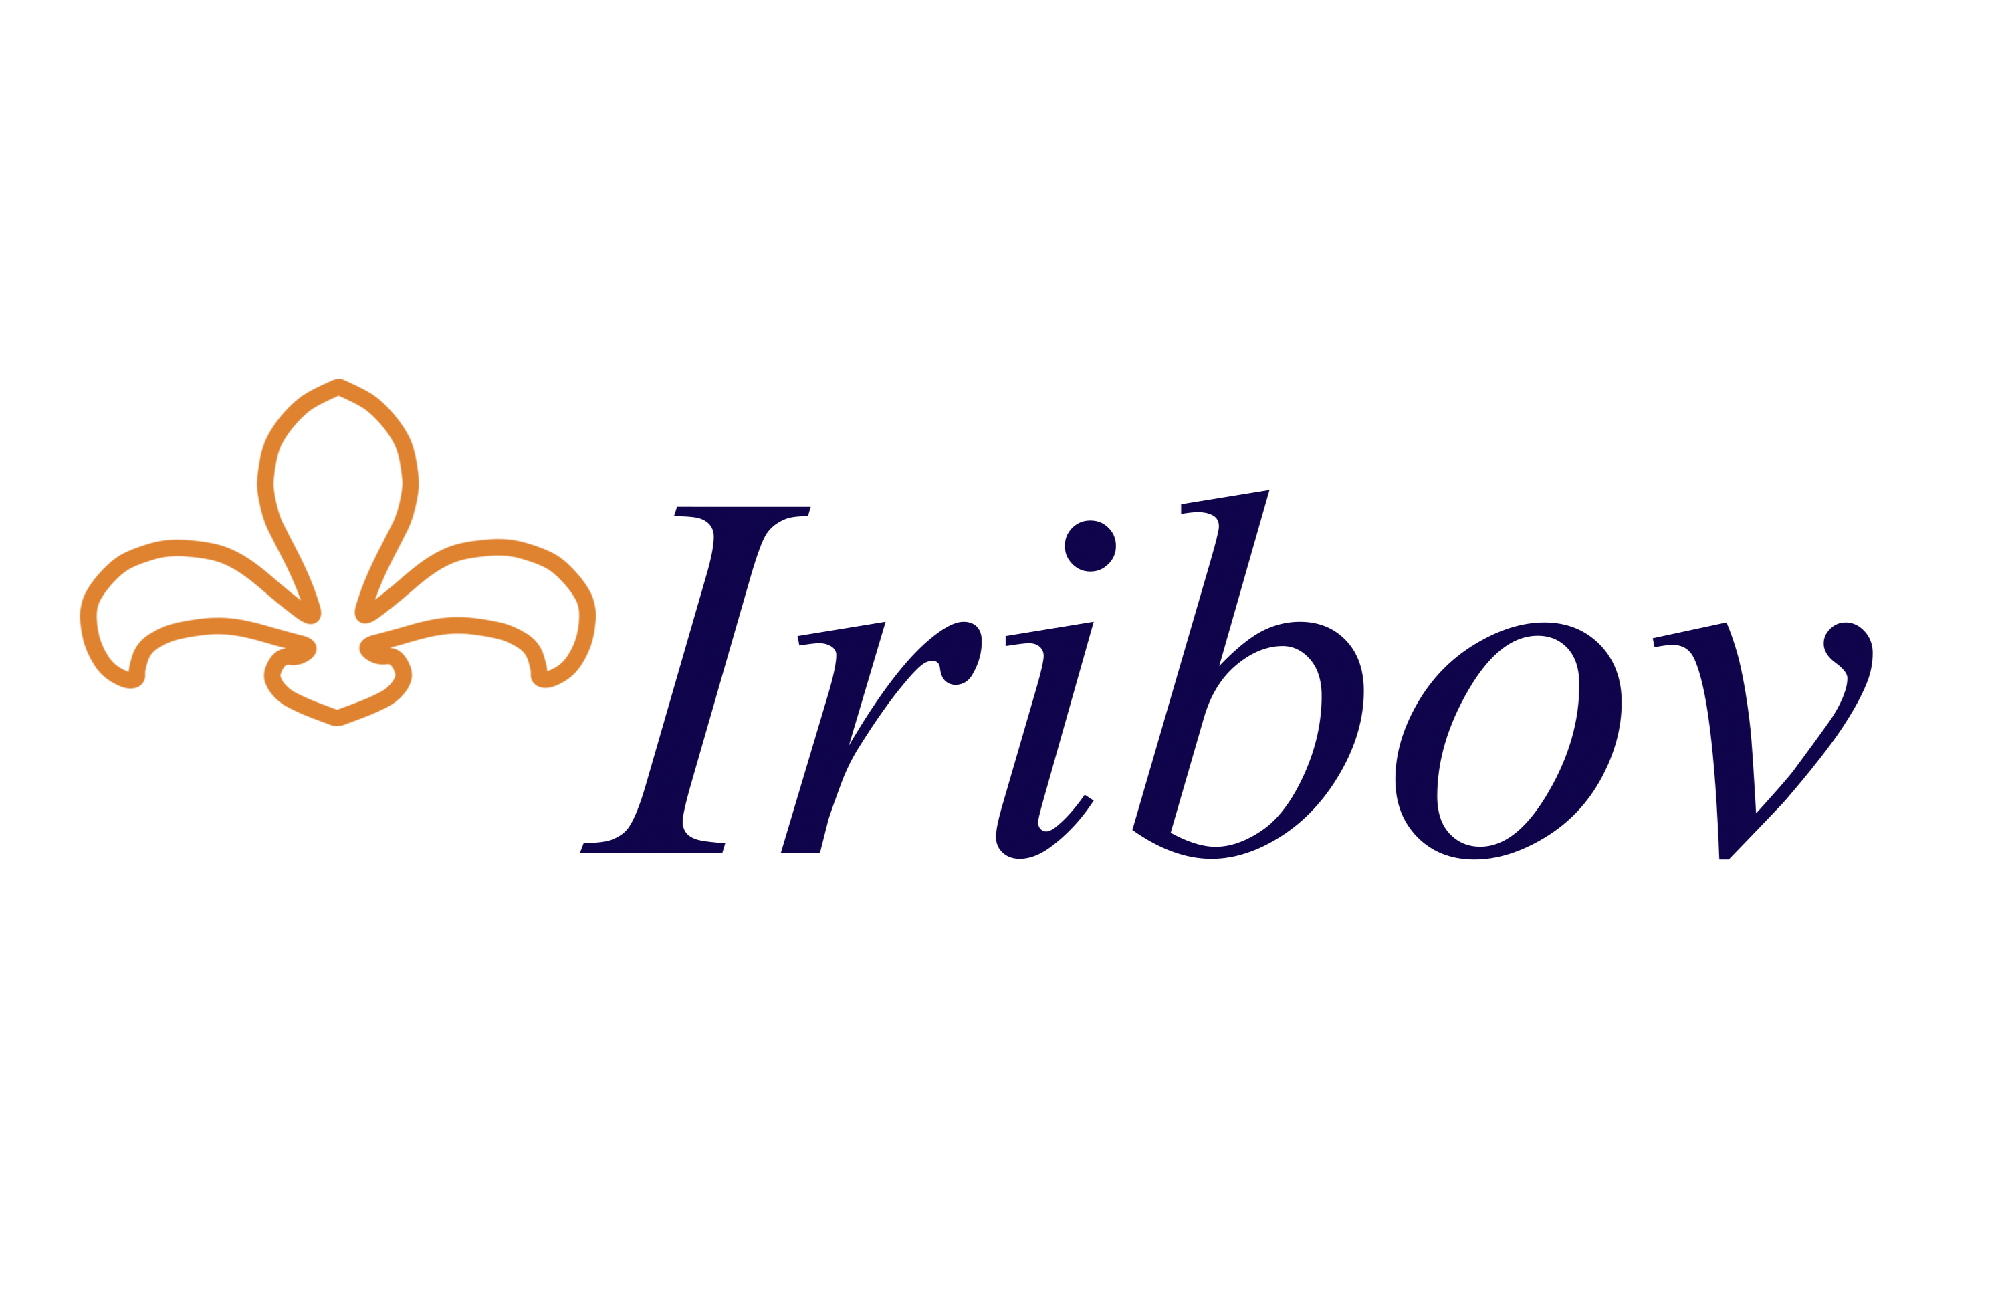

Assistant Researcher Tissue Culture

40 hours per week

Iribov
Iribov is a leading laboratory that performs services in the field of plant propagation and breeding. The main activities are tissue culture propagation of plants and various analyses of plants. Iribov has extensive expertise in more than 500 crops in both floriculture, fruit and vegetable crops. Iribov has a strong international market position as an independent supplier. With laboratories in the Netherlands, Macedonia and Ghana, Iribov is an international organization with a total of more than 500 employees. In 2022, approximately 50 million tissue culture plants will be produced.

Job description
Are you passionate about tissue culture and plants? Then the role of assistant researcher tissue culture is something for you. We are looking for the location in Heerhugowaard for a full-time assistant researcher.
You will function within the research team and will report to the coordinator of R&D. The group is engaged in research into the development of protocols for the tissue culture of new crops, new tissue culture techniques (bioreactors), somatic embryogenesis and cell biology.
Research is also being carried out into the application and implementation of tissue culture techniques to support breeding activities at clients. You will participate in various research assignments, which are carried out on behalf of the client or on behalf of the parent company. You combine modern techniques with an interest in practical work. Furthermore, you are good at clearly formulating problems and bottlenecks.

Profile
- HBO/BSc/MSc level or academic training in plant sciences;
- Good practical skill with plant tissue culture in general;
- Analytical attitude with creative and practical skills;
- Team player;
- Interest in growth of plants and plant physiology;
- Communication skills, verbal and written;
- A result-oriented and accurate working attitude (also under time pressure).

Interested?
We offer you an independent and varied position. There is room for personal development and the terms of employment are in accordance with the position.

Do you recognize yourself in above mentioned profile and are you in for a new challenge?

Please send your application to:
Iribov BV Nederland
Middenweg 591b
1704 BH Heerhugowaard
T: +31 (0)72 5742427
E: hr@iribov.com
Acquisitions due this vacancy are not appreciated.

